Analysis Summary

1. Analysis results:
   * 1. Users mostly use their wearable device to track their calories burned, the steps taken, the intensity of their activities and their MET value. Relatively, Less people use it their wearable device to monitor their sleep, heart rate, or to record the change of their BMI and weight.
     2. Users are mostly in the working class who has regular working hours. The usually go to do exercise after work. It means that they are people are busy with work, some of them even get a bit chubby , but they still focus on work-life balance and strive to stay active and healthy with the help of their wearable health tracker.
2. Recommendations on marketing strategy
3. The results of this study can be applied to the marketing strategy of the Bellabeat membership, which is a subscription-based membership program that gives users 24/7 access to fully personalized guidance on nutrition, activity, sleep, health and beauty, and mindfulness based on their lifestyle and goals.
4. The target of our promotion can be the women who are very busy with work and start to have a higher body fat level, but still believe in healthy life style and want to stay active and get into a good shape with the time after work.
5. We can focus on advancing the belief of work-life balance and helping women manage their body in an flexible and friendly way with our membership.
6. Evidence
7. The table below shows the how complete the data and the number of unique user Ids in each data set in this study. From this information we can see what data users use their wearable device to record and what users care the most about. The data sets about the records of calories, intensity, MET and steps all have a completeness level above 90% and all 33 users in the study have used their device to track these data.While the data sets about sleep,heart rate are only around 50% complete and there are only 24 and 14 people use their device to track this data respectively. And the user_info data set which records BMI value and weight is only around 30% complete and only 8 users are involved.Under the comparison, we can see that most people use their wearable device to track the calories they burned, steps taken, intensity of their activity and their MET. These are the metrics they care the most about when using health trackers.

|  |  |  |  |
| --- | --- | --- | --- |
| **No.** | **Dataset** | **Completeness Level** | **Number of Fitbit users involved** |
| **1** | **calories_hourly** | 90.99% | 33 |
| **2** | **calories_daily** | 91.89% | 33 |
| **3** | **intensity_daily** | 91.89% | 33 |
| **4** | **intensity_hourly** | 90.99% | 33 |
| **5** | **MET_minute** | 90.96% | 33 |
| **6** | **sleep_daily** | 55.11% | 24 |
| **7** | **steps_daily** | 91.89% | 33 |
| **8** | **steps_hourly** | 90.99% | 33 |
| **9** | **Heartrate_hour** | 58.36% | 14 |
| **10** | **user_info** | 29.91% | 8 |
| **12** | **MET_hourly** | 90.96% | 33 |

1. The values of the health metrics - heart rate,MET, intensity, calories and steps taken have their lowest point at 3 or 4 AM in a day. And then the value gradually goes up and remains steady at some certain value from 6 AM in a day. Every metric reaches its highest point at 6 PM in the day , when people are mostly active. And then the value gradually goes down from 6 to 12 PM. The data pattern indicates that the users are mostly in the working lass who have a regular working schedule. And the usually go to do exercise after work, which is why their health metrics reach their highest point of the day. And from the very limited data from the user_info data set, the average BMI of the device users is around 25. The normal range of BMI is 18.5 – 24.9. And the average BMI of our sample group in the study is at the Overweight (Pre-obese) level. It means that they are people who are busy with work but still focus on work-life balance and strive to stay active and healthy with the help of their wearable health tracker.

(https://en.wikipedia.org/wiki/Body_mass_index)

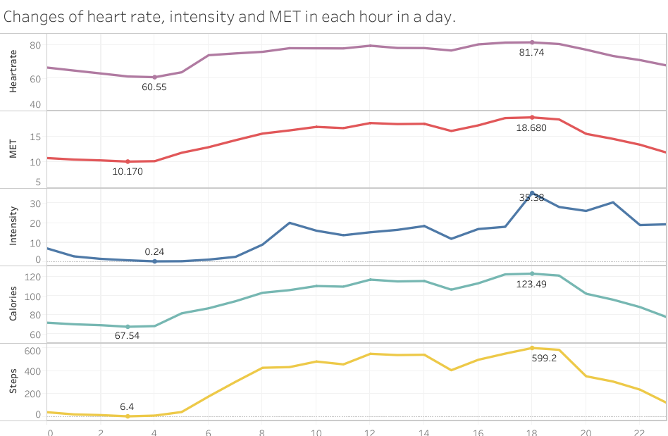

1. Most of the time people stay sedentary or lightly active in a day because they are probably sitting in front of the laptop or walking around to have some refreshment in the office. They spend around 30 to 40 minutes in a day to be truly active. People spend this period of time to run, do cardio, cycling or do all kinds of sports that they like to stay healthy after sitting in the office for a long time.

